**Import/Export Custom Device Configuration Utility**

Description

This utility is meant to provide the Custom Device developer with an API to export into a file the configuration of a Custom Device to import it later. This configuration includes the values for all the properties of the Custom Device channels including dynamically created channels.

If a Custom Device User needs to have different configuration values in his Custom Device or removes the Custom Device and adds it again, he will have to configure the Custom Device manually every time. This utility is intended to address that problem.

How to Use it?

This utility is based in the System Definition Utilities API developed by Systems Engineering. You will be able to install this utility using VI Package Manager and will also be installed as a dependency when installing the VeriStand Custom Device Project Wizard.

The NIVS System Definition Utilites palette includes 2 subpalettes: Import Export and SysDef API.

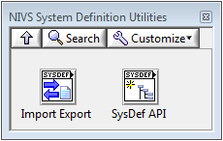

SysDef API can be used separately if you need to create a custom version of the Import Export VIs, but to provide the Import/Export functionality you will only need the VIs in the Import Export palette. SysDef.SimpleSave.vi and SysDef.SimpleLoad.vi

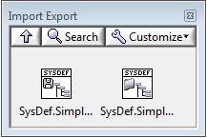

The Import/Export VIs can be called from the Initialization VI or the Main VI within your Custom Device LabVIEW project. Keep in mind that calling the Import VI from the Main VI is merging the loaded hierarchy with the current hierarchy of your Custom Device, while calling the Import VI from the Initialization VI creates the Custom Device hierarchy from scratch using the configuration values loaded from the file. We strongly recommend using the Import VI only from the Initialization VI.

We have added this functionality to the template generated by the Custom Device Project Wizard. This implementation will be described next.

**Export**

Export functionality is implemented in the template as a Runtime Menu. Adding a Runtime Menu involves adding a page into Extra Pages folder and adding some code to your XML.

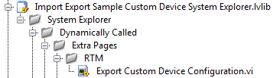

The VI is already there in the template. If you want to create another page for a Runtime Menu you can use the RunTimeMenu templates found in the Custom Device API.lvlib>>Templates>>RTM.

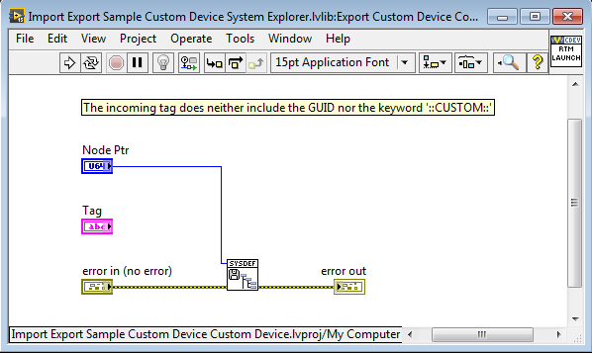

Here is how the code added to the XML Main Page section looks like:

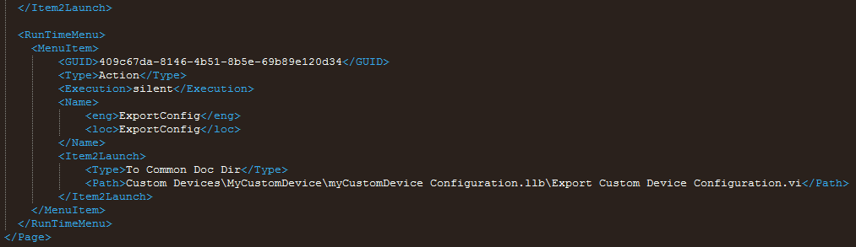

The GUID for the Runtime Menu is the same as the Main Page GUID.

When building your Custom Device you will be able to Export your configuration by doing right-click on your Custom Device.

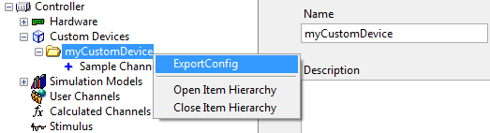

A dialog box will ask you where you want to save the .dat configuration file.

**Import**

Import functionality is implemented in the Initialization VI. The shipping Initialization VI code looks like this:

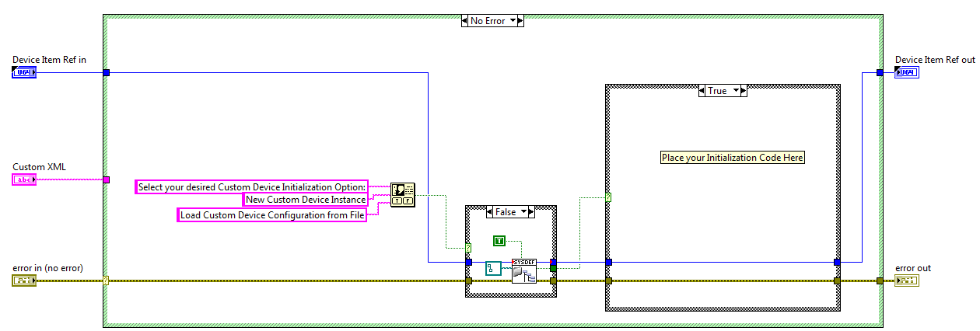

When a Custom Device is added to your System Definition File, a dialog box will ask you if you want to create a “New Custom Device Instance” or if you want to “Load a Custom Device Configuration from a File”.

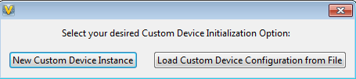

If you select “New Custom Device Instance” your Initialization VI code will execute creating a completely new instance of your Custom Device. If you select “Load a Custom Device Configuration from a File”, the user will be prompted to select the configuration file. If he selects a file, the Custom Device will be created using the loaded configuration, if the user presses the Cancel button when prompted to select the file, a regular new instance of the Custom Device will be created.